**Data Warehousing & Data Mining LAB - G2  
EXPERIMENT 10**

**-** ASHISH KUMAR  
 - 2K18/SE/041

# Aim:- Write a program in Python Language to implement Model Evaluation (Cross Validation and Generate Confusion Matrix).

**Theory: - Cross-Validation** is a validation technique designed to evaluate and assess how the results of statistical analysis (model) will generalize to an independent dataset. Cross-Validation is primarily used in scenarios where prediction is the main aim, and the user wants to estimate how well and accurately a predictive model will perform in real-world situations. Cross-Validation seeks to define a dataset by testing the model in the training phase to help minimize problems like overfitting and underfitting.

### Benefits of Cross-Validation

* It helps evaluate the quality of your model.
* It helps to reduce/avoid problems of overfitting and underfitting.
* It lets you select the model that will deliver the best performance on unseen data.

**K-Fold Cross Validation**: In this method, we split the data-set into k number of subsets(known as folds) then we perform training on the all the subsets but leave one(k-1) subset for the evaluation of the trained model. In this method, we iterate k times with a different subset reserved for testing purpose each time.

A **Confusion matrix** is an N x N matrix used for evaluating the performance of a classification model, where N is the number of target classes. The matrix compares the actual target values with those predicted by the machine learning model. This gives us a holistic view of how well our classification model is performing and what kinds of errors it is making.

**Note:** I have used **“iris data”** as a dataset in this experimentand used **K-Fold Cross validation** technique to generate Confusion matrix.

Picture of iris dataset:

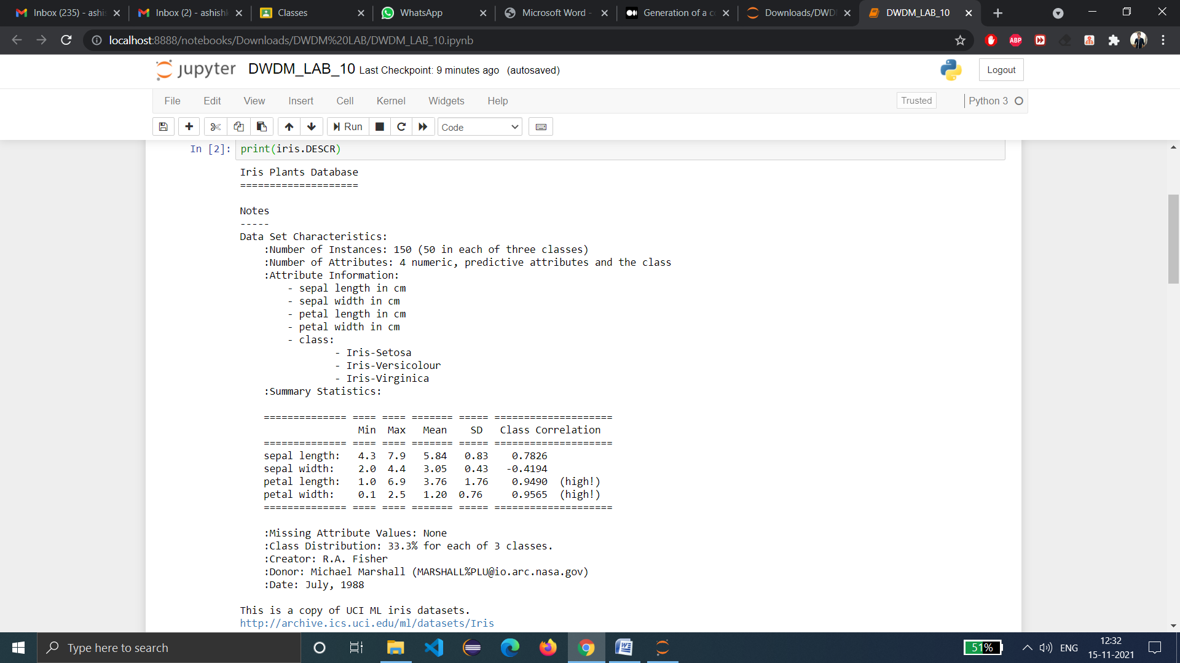

**Source Code (in python):**

import itertools

import matplotlib.pyplot as plt

import numpy as np

from sklearn import svm, datasets

from sklearn.metrics import confusion_matrix

from sklearn.model_selection import KFold

# import IRIS dataset

iris = datasets.load_iris()

data = iris.data

target = iris.target

class_names = iris.target_names

class_names

labels, counts = np.unique(target, return_counts=True)

print(iris.DESCR)

def evaluate_model(data_x, data_y):

k_fold = KFold(10, shuffle=True, random_state=1)

predicted_targets = np.array([])

actual_targets = np.array([])

for train_ix, test_ix in k_fold.split(data_x):

train_x, train_y, test_x, test_y = data_x[train_ix], data_y[train_ix], data_x[test_ix],   
 data_y[test_ix]

# Fit the classifier

classifier = svm.SVC().fit(train_x, train_y)

# Predict the labels of the test set samples

predicted_labels = classifier.predict(test_x)

predicted_targets = np.append(predicted_targets, predicted_labels)

actual_targets = np.append(actual_targets, test_y)

return predicted_targets, actual_targets

def plot_confusion_matrix(predicted_labels_list, y_test_list):

cnf_matrix = confusion_matrix(y_test_list, predicted_labels_list)

np.set_printoptions(precision=2)

# Plot non-normalized confusion matrix

plt.figure()

generate_confusion_matrix(cnf_matrix, classes=class_names, title='Confusion matrix, without   
 normalization')

plt.show()

# Plot normalized confusion matrix

plt.figure()

generate_confusion_matrix(cnf_matrix, classes=class_names, normalize=True,   
 title='Normalized confusion matrix')

plt.show()

def generate_confusion_matrix(cnf_matrix, classes, normalize=False, title='Confusion matrix'):

if normalize:

cnf_matrix = cnf_matrix.astype('float') / cnf_matrix.sum(axis=1)[:, np.newaxis]

print("Normalized confusion matrix")

else:

print('Confusion matrix, without normalization')

plt.imshow(cnf_matrix, interpolation='nearest', cmap=plt.get_cmap('Blues'))

plt.title(title)

plt.colorbar()

tick_marks = np.arange(len(classes))

plt.xticks(tick_marks, classes, rotation=45)

plt.yticks(tick_marks, classes)

fmt = '.2f' if normalize else 'd'

thresh = cnf_matrix.max() / 2.

for i, j in itertools.product(range(cnf_matrix.shape[0]), range(cnf_matrix.shape[1])):

plt.text(j, i, format(cnf_matrix[i, j], fmt), horizontalalignment="center",

color="white" if cnf_matrix[i, j] > thresh else "black")

plt.tight_layout()

plt.ylabel('True label')

plt.xlabel('Predicted label')

return cnf_matrix

predicted_target, actual_target = evaluate_model(data, target)

plot_confusion_matrix(predicted_target, actual_target)

**OUTPUT-**

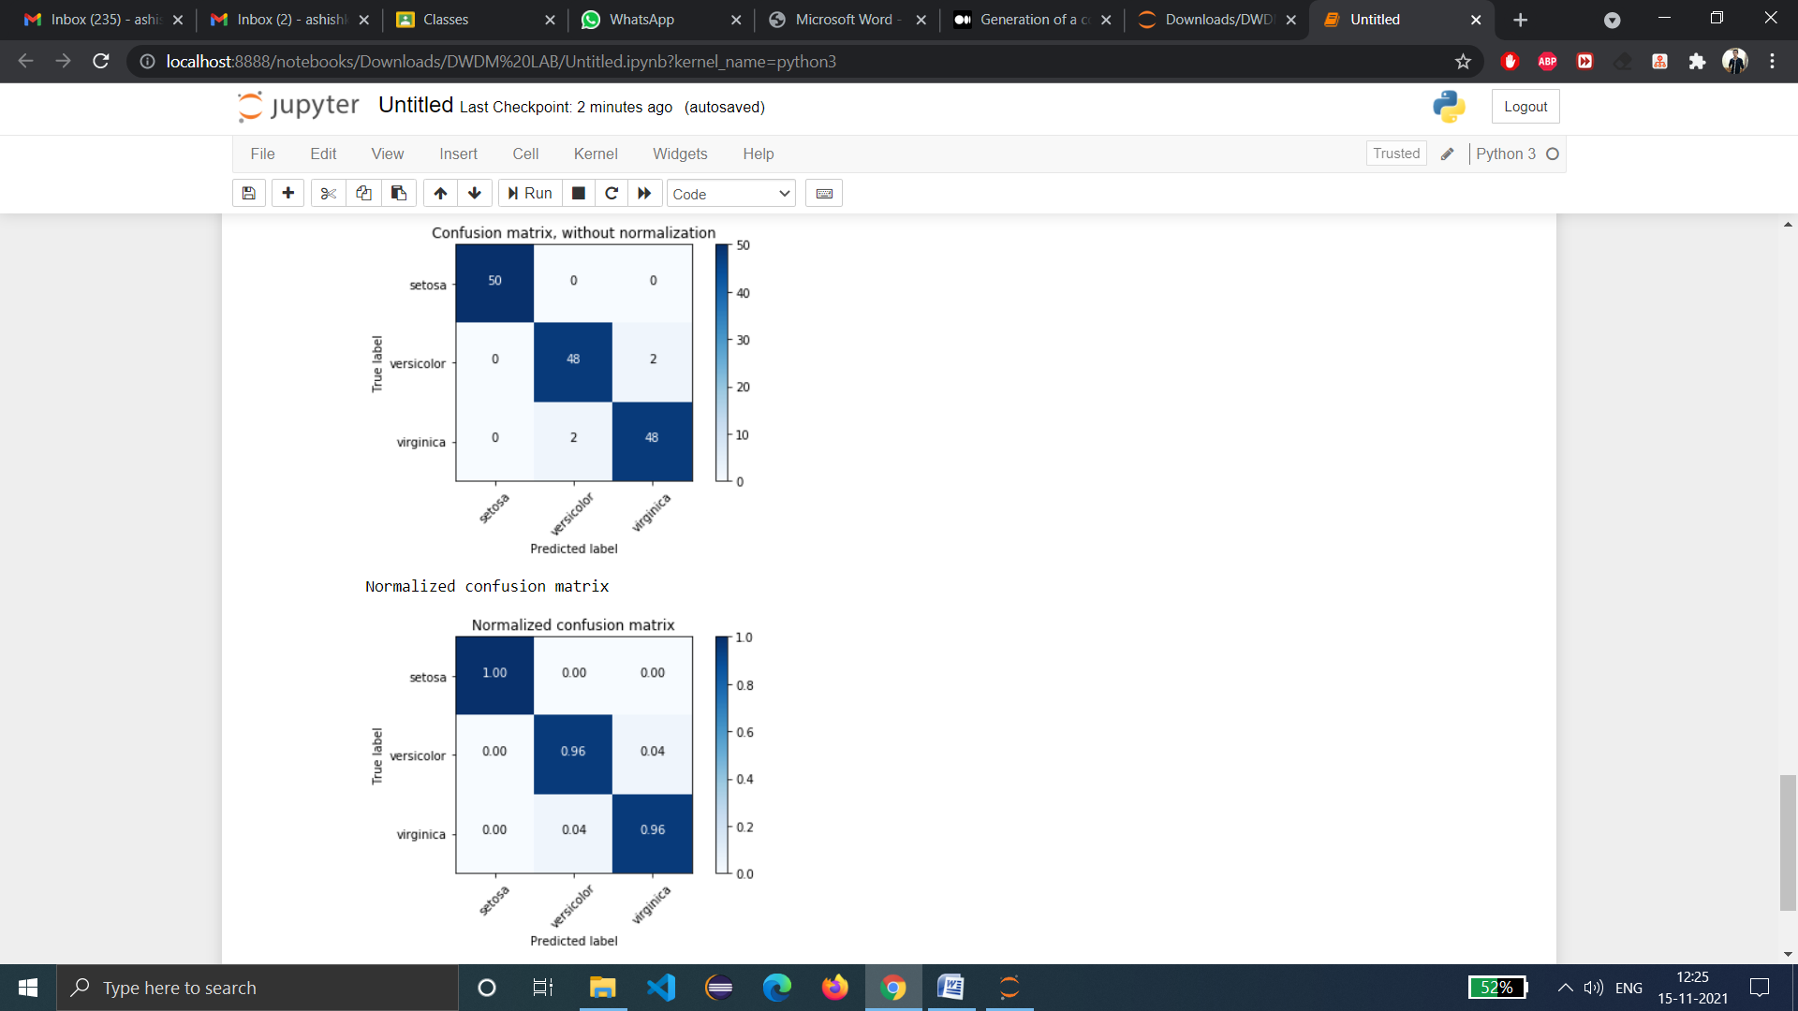

**Findings and Learning:**

* We have successfully implemented Cross validation and then generate confusion matrixin Python.
* We have learnt about the applications, strengths and weaknesses of Cross Validation and Confusion Matrix.